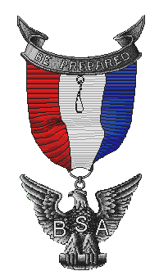

Boy Scout Troop 4019 and Scoutmaster
cordially invite you and your family to attend our

Eagle Scout Reunion

Saturday July 12, 2014
2:00 pm – 5:00 pm

Roundtop Park Athens, Pa.
Pavilion 11

A barbeque dinner is planned at a cost of $10 per person.
We would love to have all our Troop’s Eagle scouts
attend to offer inspiration to our troop.
Troop email: bsatroop4019@gmail.com
Troop website: bsatroop4019@weebly.com

R.S.V.P. by Tuesday, July 1, 2014
Checks payable to Troop 4019 and mail to

Boy Scout Troop 4019 and Scoutmaster
cordially invite you and your family to attend our

Eagle Scout Reunion

Saturday July 12, 2014
2:00 pm – 5:00 pm

Roundtop Park Athens, Pa.
Pavilion 11

A barbeque dinner is planned at a cost of $10 per person.
We would love to have all our Troop’s Eagle scouts
attend to offer inspiration to our troop.
Troop email: bsatroop4019@gmail.com
Troop website: bsatroop4019@weebly.com

R.S.V.P. by Tuesday, July 1, 2014
Checks payable to Troop 4019 and mail to

