In Celebration of



Scout’s Name

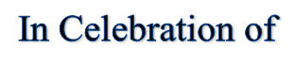

**Scout’s Name**